
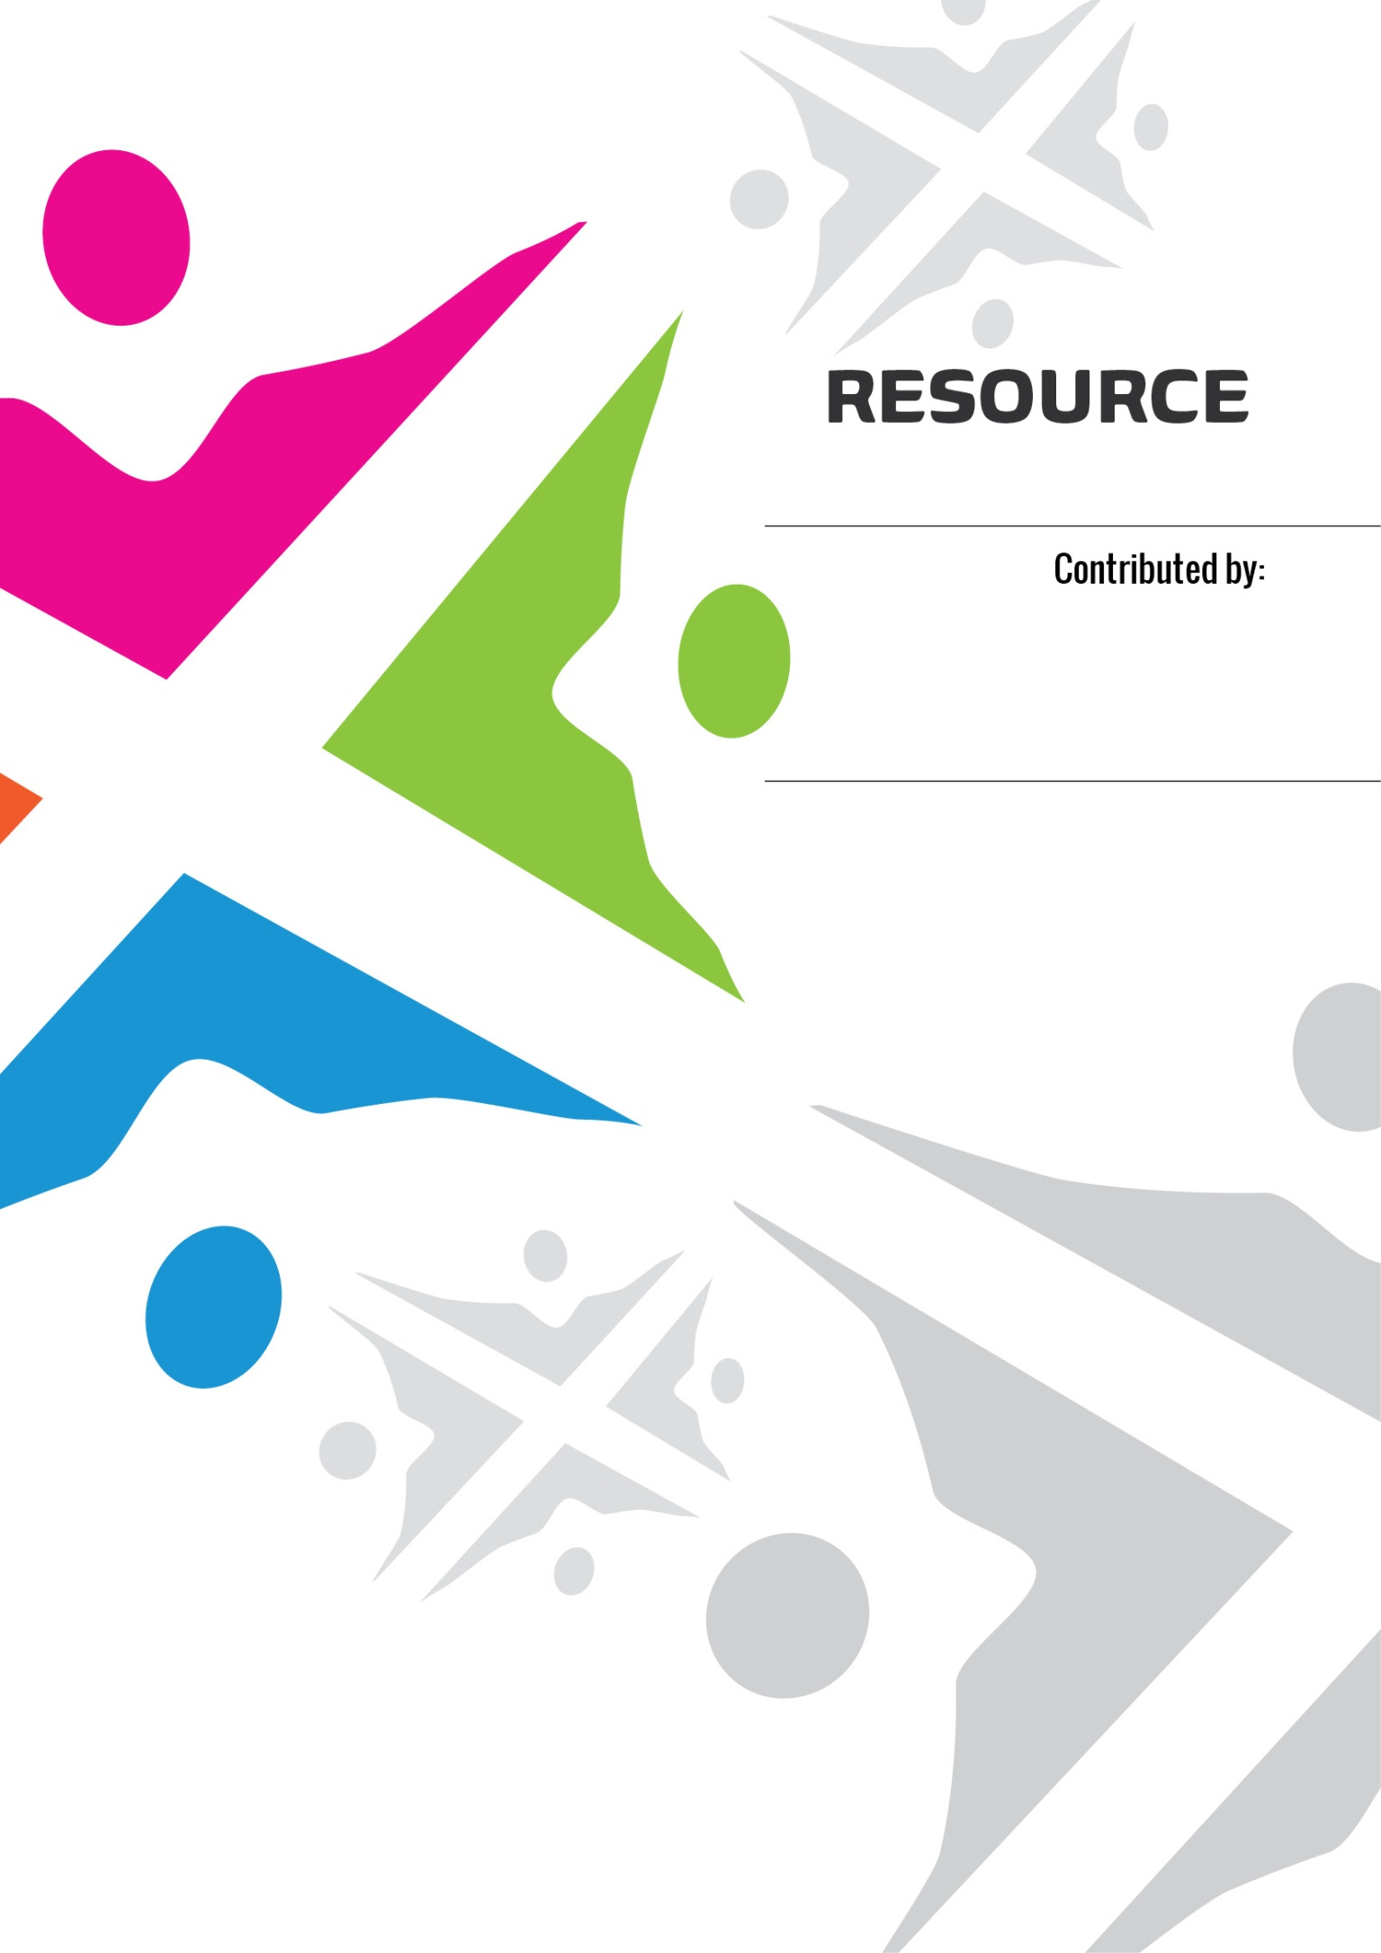
RESEARCH

Calder Avenue
Coatbridge
ML5 4JS

The Conforti Institute is working on a project to give the Catholic community the chance to give witness and voice to their own experiences and perceptions of sectarianism in Scotland today. We do this through holding listening exercises in focus groups within parishes and with Catholic groups. The Catholic Church is organised into 8 dioceses in Scotland. So far, our project is working in 6 of these: the Archdiocese of St. Andrews and Edinburgh; Dunkeld Diocese which includes Dundee and surrounding area; Galloway Diocese which includes Ayrshire and Dumfriesshire; Paisley Diocese; Motherwell Diocese and the Archdiocese of Glasgow.
Once listening exercises are complete, Conforti hopes to support communities to define and take action to address any issues which have emerged. This may well involve developing action with other Christian groups and those of no faith.
In addition to supporting community action, the information provided to us through the listening exercises will be used to write a report which will be shared with the Scottish Government's independent advisory group on sectarianism and anyone else who is interested. It is hoped that our findings will contribute to broader thinking on sectarianism and how the Scottish Government should respond to it.
Conforti Contact Here- This will link to Conforti landing page

Conforti Institute is the working title of Lanarkshire Global Education Centre, Scottish charity SC035639
The Institute is committed to integral human development, development that promotes the good of every person and the whole person; it is cultural, economic, political, social, and spiritual. In line with our commitment to integral human development, the Institute is a member of IDEAS [www.ideas-forum.org.uk ], a network of agencies and education centres which promotes a global dimension in both formal and informal education.

