
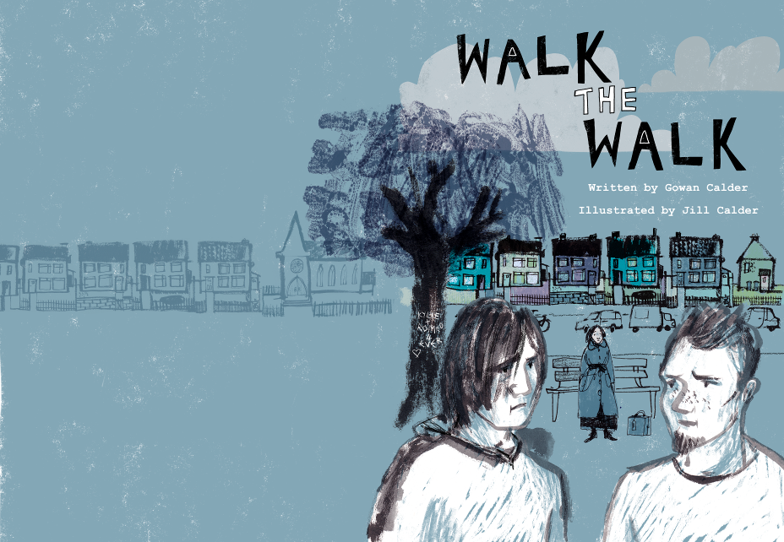

Rab McGowan and Robbie Black are firm friends. Old Firm friends, you might say.
But on their street, The Walk, there is a split between the top end and the bottom end and it sometimes feels more like a war zone than a neighbourhood.

Walk The Walk was created in collaboration with learners by author Gowan Calder and illustrator Jill Calder. The book follows the two boys on their journey along The Walk, as they learn about the sectarian conflicts that have split their community, get advice from their neighbours, and try to keep their friendship together despite it all.

You are invited to a FREE CPD training event to explore best practice approaches to working with Walk The Walk.
Funded by the Scottish Government, Walk The Walk is a brand new graphic novel from Scottish Book Trust. It is aimed at learners aged 16+ who attend literacy support, youth and community groups. The book is accompanied by a suite of learning support activities designed for both learners and tutors.

The events are free: lunch and refreshments will be provided.
Places are limited, so book early to avoid disappointment (12 slots per session).
Please scroll down for more information, and
to fill out our booking form.

Why attend?

You are invited to a CPD training event that will provide:

- an opportunity to engage with a tried and tested resource that supports literacy development in a fun and engaging way
- a chance to try out additional supporting activities yourself
- in-depth exploration of a subject (sectarianism) that can be sensitive and emotive
- a best practice guide to presenting this subject to learners

A tutor who took part in the development of Walk The Walk said:

“I think for youth workers like me... to have something else there that’s not just the book is really beneficial. [...] You can go on; you can do activities relating to the book, which maybe makes learners understand [sectarianism] better, and could actually help staff understand it a bit more, too.”
Brian Borland, South Ayrshire Youth Forum
Dates and locations:

Location: Edinburgh  Date: Wednesday 2nd September  Time: 10.00am to 4.00pm  Venue: Scottish Book Trust | Location: Glasgow  Date: Wednesday 16th September  Time: 9.30am to 1.00pm  Venue: City Halls
Location: Inverclyde  Date: Thursday 17th September  Time: 9.30am to 1.00pm  Venue: Greenock Town Hall | Location: Oban  Date: Thursday 1st October  Time: 9.30am to 1.00pm  Venue: Lorn House, Albany Street
Location: Perth  Date: Wednesday 7th October  Time: 9.30am to 1.00pm  Venue: The Subud Centre | Location: Glasgow  Date: Wednesday 28th October  Time: 10.00am to 4.00pm  Venue: Deaf Connections, Norfolk Street
Location: Stranraer  Date: Monday 2nd November  Time: 9.30am to 1.00pm  Venue: TBC | Location: Dumfries  Date: Tuesday 3rd November  Time: 9.30am to 1.00pm  Venue: TBC
Location: Aberdeen  Date: Wednesday 11th November  Time: 9.30am to 1.00pm  Venue: TBC | Location: Galashiels  Date: Wednesday 27th January 2016  Time: 9.30am to 1.00pm  Venue: TBC

Who can attend?

Those who work with young people in formal and informal settings will benefit from attending this CPD training event, including:

- Literacy tutors working in schools, libraries, colleges, community and family learning centres;
- Youth workers;
- Support workers delivering educational or personal development programmes in young offenders institutions;
- Literacy tutors and youth workers linked to local and national voluntary organisations and youth volunteering programmes.

Lunch and refreshments will be provided free of charge at this event. Places are limited (12 slots per venue), so book early to avoid disappointment. To book a place, please complete and return the booking form which can be found below.

Aim

The aim is to create an opportunity for tutors and youth workers to experience a resource that has been tried and tested. Walk The Walk is learner-centred and helps learners aged 16+ to develop their literacy – via the storytelling medium and the book’s supporting activities – while also exploring strategies for tackling sectarianism in their community.

Specific Learning Objectives – What will I learn?
- How to harness interactive storytelling as a tool to help recognise the different approaches by which problems can be challenged, and how to use these to affect change;
- How to develop confidence in dealing with challenging subjects (e.g. sectarianism) with learners;
- Where to find additional support materials to develop this approach further.

Post-event Objectives – What can I do next?
- Share this approach with your peers and help to cascade the benefits;
- Ensure you have received copies of Walk The Walk;
- Go online to www.scottshbooktrust.com/walkthewalk to access additional support materials and accessible versions of Walk The Walk (PDF with audio).

“Reading [Walk The Walk], people can’t just say ‘oh, he’s just doing that because he’s a Celtic fan,’ or whatever. They are forced to think ‘this is someone’s sister’ instead.”
Danny, a learner at Adult Education Bathgate

Booking form - Please complete one form per person. To secure a place, forms should be completed and returned by email or post to Emma Tadrous at Scottish Book Trust using the address shown below.

Your details:

Name: |  |  |  |  | Job Title:
Organisation Name:
Address:
Telephone: |  |  |  | Email:
I wish to attend on (please tick one box):
Wednesday 2nd September (Edinburgh):10.00am to 4.00pm [ ]
Wednesday 16th September (Glasgow): 9.30am to 1.00pm [ ]
Thursday 17th September (Inverclyde): 9.30am to 1.00pm [ ]
Thursday 1st October (Oban): 9.30am to 1.00pm [ ]
Wednesday 7th October (Perth): 9.30am to 1.00pm [ ]
Wednesday 28th October (Glasgow):10.00am to 4.00pm [ ]
Monday 2nd November (Stranraer): 9.30am to 1.00pm [ ]
Tuesday 3rd November (Dumfries): 9.30am to 1.00pm [ ]
Wednesday 11th November (Aberdeen): 9.30am to 1.00pm [ ]
Wednesday 27th January 2016 (Galashiels): 9.30am to 1.00pm [ ]
Do you have any requirements that we should know about, e.g. access, dietary? |  |  |  |  |  |  | Yes/No
If yes, please specify:

Return completed form to:
Emma Tadrous, Adult Learning Administrator
Email: emma.tadrous@scottishbooktrust.com
Post: Emma Tadrous, Scottish Book Trust, Sandeman House, Trunk’s Close, 55 High Street, Edinburgh EH1 1SR
Tel: 0131 524 0160

